Image Classification Using CNN (Convolution Neural Networks) Algorithm

In this project we are using python KERAS and Google TENSORFLOW CNN algorithm to classify images, CNN algorithm can predict images correctly up to 90% which is better prediction accuracy compare to all other algorithms such as SVM, KNN etc. To classify images using CNN we need to train CNN network with all possible images and when new images uploaded then CNN train model will be applied on this new image to predict or identify image.

CNN working procedure

To demonstrate how to build a convolutional neural network based image classifier, we shall build a 6 layer neural network that will identify and separate one image from other. This network that we shall build is a very small network that we can run on a CPU as well. Traditional neural networks that are very good at doing image classification have many more parameters and take a lot of time if trained on normal CPU. However, our objective is to show how to build a real-world convolutional neural network using TENSORFLOW.

Neural Networks are essentially mathematical models to solve an optimization problem. They are made of neurons, the basic computation unit of neural networks. A neuron takes an input (say x), do some computation on it (say: multiply it with a variable w and adds another variable b) to produce a value (say; z= wx + b). This value is passed to a non-linear function called activation function (f) to produce the final output (activation) of a neuron. There are many kinds of activation functions. One of the popular activation function is Sigmoid. The neuron which uses sigmoid function as an activation function will be called sigmoid neuron. Depending on the activation functions, neurons are named and there are many kinds of them like RELU, TanH.

If you stack neurons in a single line, it’s called a layer; which is the next building block of neural networks. See below image with layers

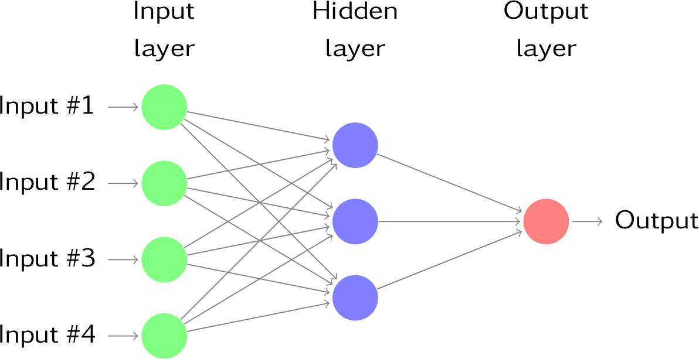

To predict image class multiple layers operate on each other to get best match layer and this process continues till no more improvement left.

Screen shots

Double click on ‘run.bat’ file to get below screen

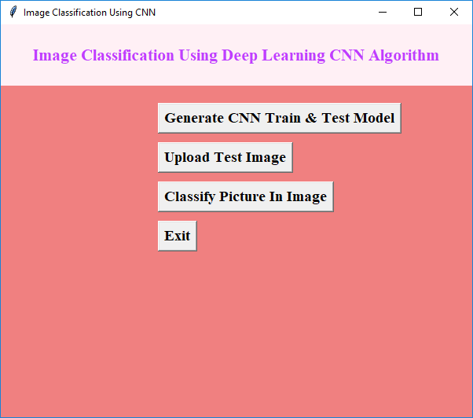

In above screen click on ‘Generate CNN Train & Test Model’ to generate CNN model with all images given inside data folder. In this application I am building CNN model with CAR, CAT, DOG, PLANE and PERSON images. This application can identify or predict images up to 90% and this CNN can work up to 100% also but we need to train it with all possible images and high processing CPU. So in this normal CPU my generated model can identity above images with 90% accuracy. Now click on ‘Upload Test Image’ button to upload image

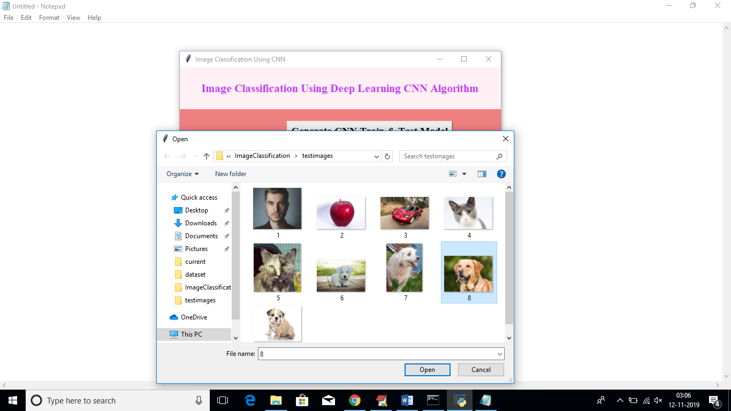

In above screen I am uploading image called 8.jpg which contains dog picture.

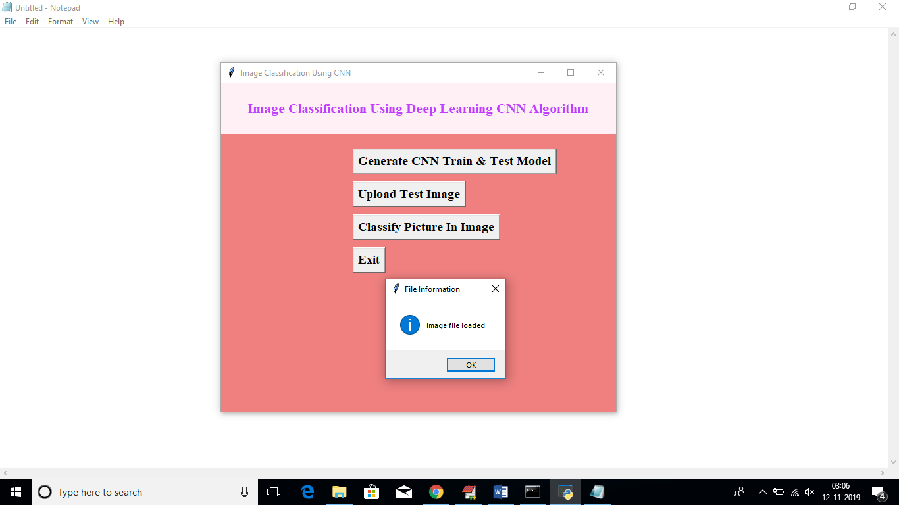

After uploading image click on ‘Classify Picture In Image’ button to predict photo in uploaded image

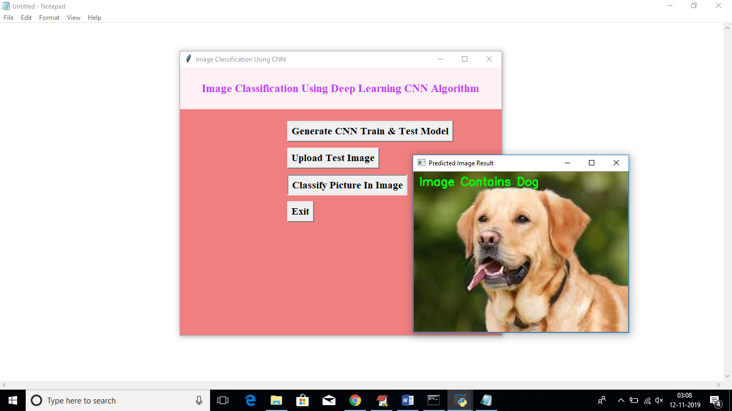

In uploaded image in above screen we can see application classify image as Dog. Similarly u can test with other images